Kubernetes

Setup using Kubeadm any of the above

1. <https://computingforgeeks.com/install-kubernetes-cluster-on-centos-with-kubeadm/>

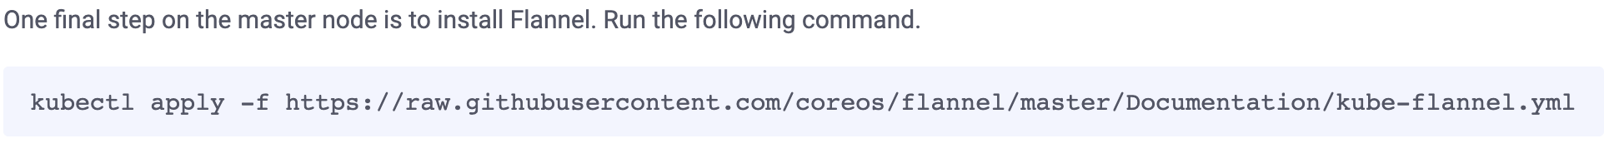

kubectl apply -f https://raw.githubusercontent.com/coreos/flannel/master/Documentation/kube-flannel.yml

1. <https://www.vultr.com/docs/deploy-kubernetes-with-kubeadm-on-centos-7>

<https://kubernetes.io/docs/concepts/cluster-administration/addons/>

Don’t forget to open the specified port in the ip after kube init 6443

Verify using

> kubectl get nodes

>kubectl create deployment dep_name –image=httpd {creating a pod}

> kubectl get deployment {

> kubectl get pods

>kubectl get deployment

>kubectl get deployment -o wide { we can use -o wide option to any Kubernetes commands}

>kubectl delete deployment dep_name

This deployment makes sure the pods are running even if the pods gets deleted

Deployment is the configuration of the pod

We can even create pods with out creating deployment

a pod is the smallest unit of Kubernetes used to house one or more containers and run applications in a cluster, while deployment is a tool that manages the performance of a pod.

>

Kubeadm doesnot install cloud controller only available in eks and kops installation methods we need to do additional settings for load balancer and autoscaling in kubeadm method

Pod – container

Deployment is pod configuration

>kubectl scale deployment dep_name --replicas=any number

>kubectl expose deployment dep_name --type=LoadBalancer --port:serviceport{canbe any number} –target-port=8080 {application port}like the right hand side port number in docker

Node port will take a random value from 30000-32700

>kubectl create deployment dep1 --image=httpd

>kubectl expose deployment dep1 --type=NodePort --port=90 --target-port=80 🡪80 is the default port of httpd

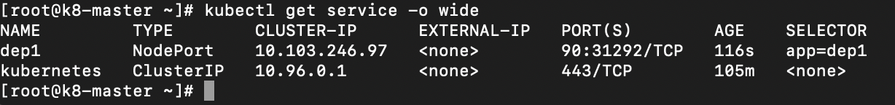

now we have to enable port 31292 but to know where run kubectl get pods to see which node the app is running on

KOPS=kubernetes operations

Unlike in kubeadm where we created master and worker nodes in kops cluster when we attach the role with above permissions it will manage the master and worker node by itself.